VPN Client Configuration

Created by: Sushil Zope
Date:29.08.2019

VPN Client Configuration

Installing the New VPN Client on your system
a) https://securenet01.iasys.in:4430/
Use your Windows login credentials to login in Firewall Portal
Usernames: Sampada.Karande
Password: use login password
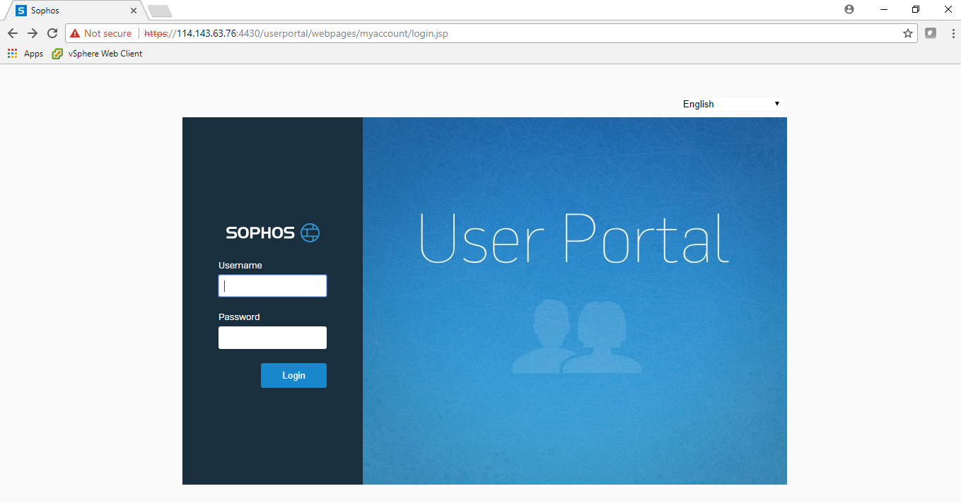

b) Download client and Configuration for windows on first option to be install on Windows Operating System & For Apple- MAC OS or Linux Systems select Third option all the setting will be configured automatically

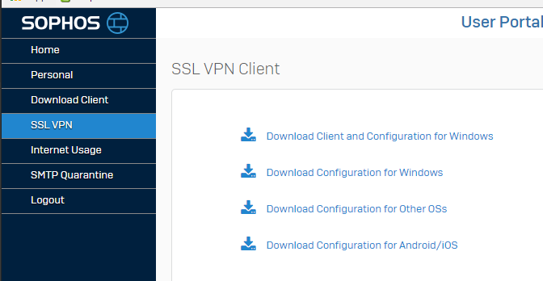

- Your domain login exe will be get downloaded on your system
For eg. Yourdomainname@iasys.com__ssl_vpn_client.exe
d) Right Click on the exe and perform Run as Administrator to install the Sophos VPN Client
e)If UAC (User Access Control) Message window gets pop us select on Yes to proceed for further installation

f)Select Next for installation of Sophos VPN Client Setup
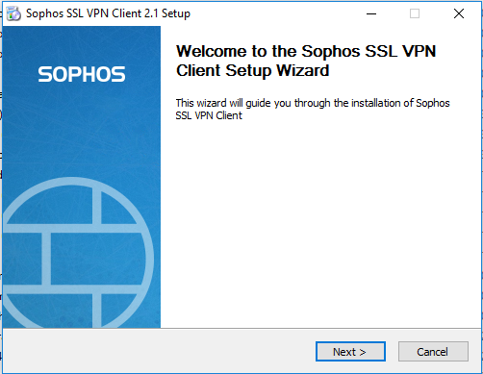

g)Select on “ I Agree” to proceed further
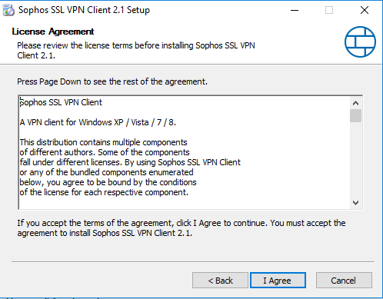

h)Select on install to proceed further
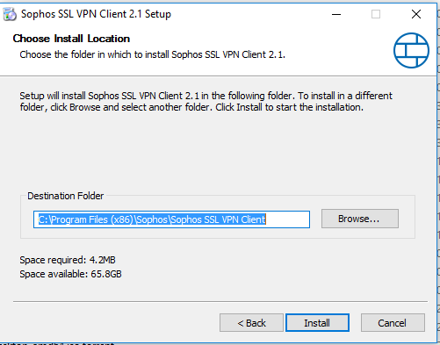

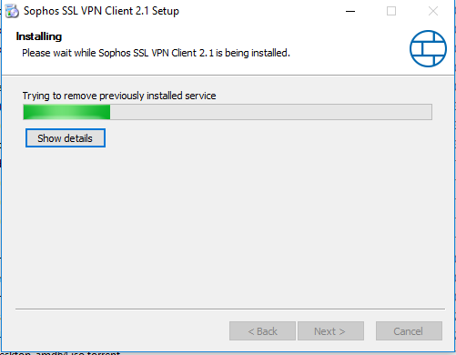

Select on Next
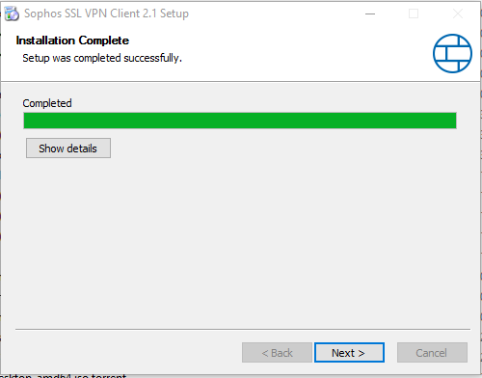

Installation Finished
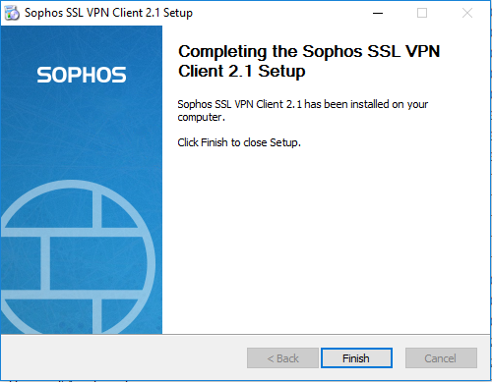

Sophos icon on Task Bar

- Right Click on the Sohos Link bar and select on connect
- Use your domain login id and password to connect to VPN
- Once the connection is success full the ikon will become from Red to Green

You can access allowed URL or Network once the VPN Connectivity is success full

For your reference
You Can Access Remote Desktop of your system :172.16.131.33

Run -→ mstsc-→
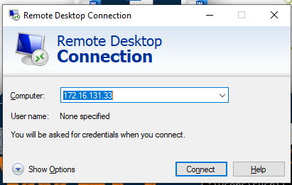
Enter Your User name and Password verify domian name :iasys\Sampada.Karande

